# AI Poker

## Introduction

Poker is a type of card game, using a standard 52-card deck, in which players bet on the value of the card combination (”hand”) in their possession, by placing a bet into a central pot. The winner is the one who holds the hand with the highest value according to an established hand rankings hierarchy (rare card combinations are more valuable than common), or otherwise the player who remains in the hand after all others have folded, and wins the current pot.

AI Poker is a poker game where the players are autonomous java program run from mobile phones. The variant of poker used by AI Poker is called five-card draw[1]. Note that this is not the same as Texas Hold ‘Em, the currently most popular poker variant.

## Requirements

AI Poker requires that a minimum of three AI Poker MIDlets (java programs for mobile phones) are run simultaneously; one server and two clients. The server controls the whole game while the clients participate in the game, playing against each other. A maximum of five clients can be connected to the server at the same time, playing against each other. This is explained in more detail in the chapter “Playing AI Poker”.

## Playing the game

In simple terms, AI Poker works like this: The server application allows clients to connect to it, and once all clients are connected the game starts. The game is controlled by the server. When a player needs to make a decision, the server sends a query to the player.

Once started, the game goes in a loop until only a single player remains (has chips left). The loop, controlled by the server, performs these actions each playing round:

1. The server informs all the players how many chips each player has.
2. The players receive five cards each from the server.
3. A forced bet (ante) is drawn from each player and put into the pot.
4. The first betting round.[2]
5. The draw phase, in which each player is offered to discard some of the cards on hand and receive new cards as replacement for the discarded. The player chooses the number of cards (between none and all) to discard.
6. The second betting round.
7. The showdown, which determines the winner of the round. The winner receives the contents of the pot. (In case of multiple winners, the pot is split.)

Each betting round starts with a player making an opening action: ”check,” which is to not place a bet (the opportunity to open moves to the next player); ”open,” which is to make the first bet; or going “all-in”, which is to open with all the players remaining chips. Once the round has been opened each player may ”fold,” which is to drop out of the hand losing any bets they have already made (but not risking any more); ”call,” which is to match the highest bet so far made; ”raise,” which is to increase the previous high bet; or go “all-in”, which is to put all the players remaining chips in the pot.

Welcome to AI Poker!

# Programming

## Programming in Java for mobile phones

Java by itself is platform independent and there is no difference in the language between different platforms. However, there are still notable differences between developing in Java for desktop applications and developing in Java for mobile phones. Here is a short list of major differences:

* Java for mobile phones is called Java ME[3], just like java for desktop applications are called Java SE[4]. Java ME programs are called MIDlets, just like Java programs for (desktop) web browsers are called applets.
* Java ME for mobile phones consists of a configuration (CLDC), a profile (MIDP) and optional extension packages[5]. Especially the support for extension packages differ between different phones, making the platform more diverse than the PC platform.
* The API for Java ME is much smaller than the API for Java SE.
* Generics does is not supported.
* Making the user interface look exactly the same on all platforms are not easy:
  + If the standard GUI components are used, they differ between different mobile phones (especially between different brands) and between mobile phones and mobile phone emulators. Developing a GUI in NetBeans becomes less of WYSIWYG[6] and more of WYSISYI[7].
  + If the user interface is drawn manually, different screen sizes, different key pads and different colors make it difficult to adapt to different mobile phones.
* Internet access is very much possible, but needs to be run from a thread not handling the applications GUI or the application will dead-lock.

## Getting started with the programming

### Downloading NetBeans

NetBeans 6.1 with Mobility Pack: <http://download.netbeans.org/netbeans/6.1/final/>.

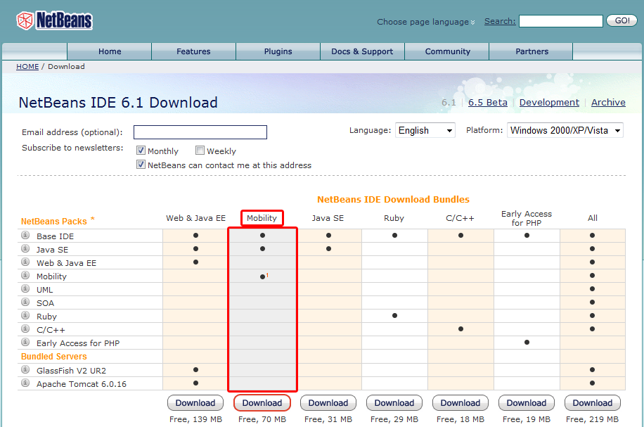

### Downloading additional emulators

While NetBeans 6.1 with Mobility Pack includes a mobile phone emulator developed by Sun that can be used to test AI Poker algorithms on the desktop, the Sun emulator is not as accurate as the emulators provided by the major mobile phone companies, including Sony Ericsson and Nokia. If such emulators are downloaded, NetBeans can be set up to use them instead of the Sun emulator.

### Documentation

After installation of NetBeans 6.1 with Mobility Pack, the API documentation for CLDC 1.1 and MIDP 2.0 can be found in C:\Program Files\NetBeans 6.1\mobility8\WTK2.5.2\docs\api\midp\index.html on a typical Windows computer.

### Opening the project

The AI Poker project is opened like any other project in NetBeans, by locating the folder. However, the project has some external dependencies that NetBeans might need help to find. The external dependencies are located in the “External” folder relative the project folder.

### Embedding AI functionality

The class PokerClient should be modified. Strictly speaking, most of the info*-methods are only to inform what actions other players (or you!) do so if the information is not needed, changing the method can be skipped, but the query*-methods are required to be changed or the program will fail.

The methods in the PokerClient class are called from the abstract base class PokerClientBase, that interprets messages sent from the server.

### Compiling and running the project

The program are compiled like any other NetBeans project and when run, a mobile phone emulator will start and allow you to test the MIDlet on your desktop computer. The emulator also allows you to debug your application.

The compilation will generate two files and put them into the projects dist-folder: PokerApplication.jar and PokerApplication.jad. The JAD file is a text file that describes the content of the jar file. You typically need only the JAR file to install the program on a telephone.

### Installing the AI Poker MIDlet on a mobile phone

The exact installation procedure differs between different mobile phones, but two common, mutually exclusive, ways to install the program are:

* Connecting the mobile phone to the computer using a USB cable, transferring the JAR file from the computer to the mobile phone and then using the mobiles file browser to open and install the JAR file.
* Uploading the JAR file from the desktop to a web server, then using the mobile phones web browser to enter the web address of the JAR file and download and install the program.

# Playing AI Poker

## Starting the AI Poker MIDlet

### Mobile Phone prerequisites:

* It is required that the mobile phones that are used to play AI Poker can run Java applications that are compatible with MIDP 2.0 and CLDC 1.1 (any modern phone).
* It is recommended that the mobile phone that is used to play AI Poker has a resolution of 240x320 pixels (most new phones except budget phones).
* It is required that the mobile phone acting as server must have WLAN.
* It is strongly recommended that the mobile phones acting as clients have WLAN.

### About the WLAN requirement

Theoretically, a mobile phone could be a server and connect to the internet using the mobile phone network. However, it seems that that is not possible in practice. Mobile phone operators typically assign mobiles IP addresses that are private, preventing access to them from outside their own network. However, tests during the development of AI Poker have shown that even mobile phones connecting using the same mobile phone network cannot access each other, for reasons not further research. Therefore, it seems that the server phone must have WLAN and connect to the net using the WLAN in order for the program to work.

If the clients do not have access to the same local network as the mobile phone, they must connect to the server phone using the public address (typically the IP address) of the phone. That means that the gateway of the server phones LAN must forward all communication for the specified port to the server phone. In order to avoid this advanced extra step, and to remove the cost of mobile internet traffic, it is strongly recommended that the client connects to the same network as the server phone using WLAN.

### Recommended mobile phones

The following list contains some models that should work with AI Poker. The program probably works with a lot of other phones that supports WLAN as well, but that is not tested. Some mobile phones with WLAN only support AI Poker as client, not as server (noted with HTC, a Windows Mobile phone).

* Sony Ericsson G705
* Sony Ericsson C905
* Sony Ericsson XPERIA X1
* Sony Ericsson G900
* Sony Ericsson W960
* Nokia N85
* Nokia N79

### Playing the AI Poker MIDlet on the computer

As the screen shots below show, it is very much possible to run several instances of the mobile phone emulator from within NetBeans. This makes testing the program much easier. Note, however, that starting the programs from within NetBeans at (almost) the same time may result in errors. In order to avoid that, wait a little while after starting one instance of the MIDlet before starting the next instance of the MIDlet.

### Mix-and-match, clients from both mobile phone and computers

If the mobile phones and the computers all are connected to the same LAN, as recommended, connecting some AI Poker instances running from mobiles with other AI Poker instances running from emulators in computer platforms should not be a problem given that firewalls do not hinder communication.

## Running the AI Poker MIDlet

### Server or client

When AI Poker is started, you must choose whether you want to run it as a server or as a client.

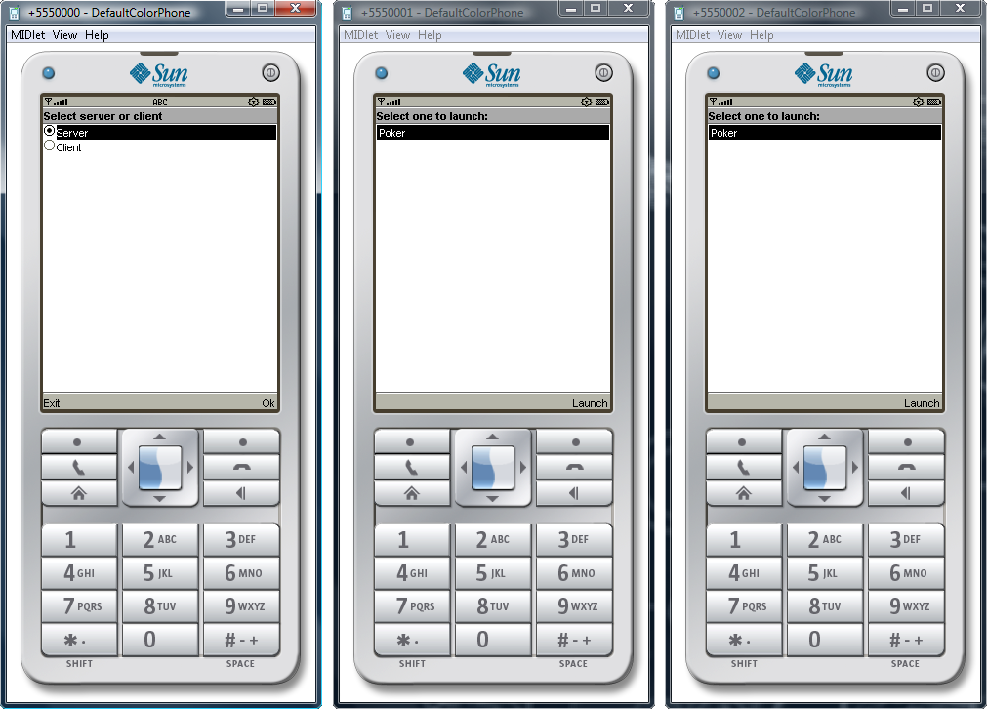

AI Poker requires that a minimum of three and a maximum of six AI Poker MIDlets run simultaneously: One server and two to five clients[8]. The server controls the whole game while the clients participate in the game, playing against each other.

When the AI Poker server is started, there are several settings that can be changed by the user:

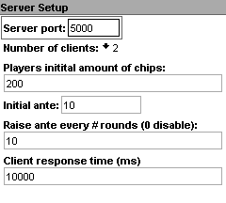[9]

1. The server port is set to 5000 as default, but it can be changed to any suitable number.
2. The default number of clients is two, in order to simplify testing.
3. The amount of chips is set to 200 for each player, but can be changed.
4. The initial ante is set to 10, but can be changed to any number between 1 and 100.
5. The ante can be doubled for every round that is a multiple of the specified value. If the default values are kept, the ante is 10 round 1-10, 20 round 11-20, 40 round 21-30, 80 round 31-40, etc.
6. The client response time is set to 10 000 ms, but can be changed to any strictly positive number. If a player does not respond to a query from the server within the specified time, the server disconnects the player.

In the next step the server application shows its local and public IP-address:

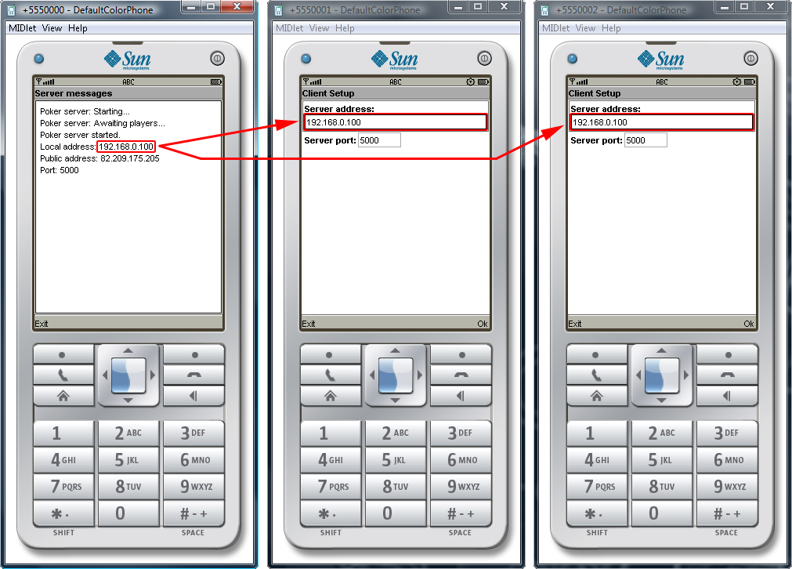

When an AI Poker client is started, there are only two settings that can be changed: The server address and the server port. As the previous screen shot shows, both are displayed on the servers screen.

* If you are connected to the same LAN as the server, as recommended, you should enter the servers local IP address in the clients setup; otherwise, use the Public address.
* It is strictly speaking not necessary to enter an IP address as the servers address; if the server has an associated name it can be used instead. If both the server and the client are run on the same computer, the client can use localhost as the servers address.

# AI Poker rules

Players in AI Poker act in turn, in clockwise rotation.

The game starts by forcing each player set an Ante (a forced bet). Once the bet has been set, each player will receive fire cards from the server.

When it is a player's turn to act, the first action he takes binds him to his choice of action and changing his action after seeing how other players react to his initial action is not permitted. Once each player has received five cards the round can start. The first player can then choose to make one of a few specific actions:

Until the first bet is made each player in turn may ”check,” which is to not place a bet, or ”open,” which is to make the first bet. After the first bet each player may ”fold,” which is to drop out of the hand losing any bets they have already made; ”call,” which is to match the highest bet so far made; or ”raise,” which is to increase the previous high bet.

Each game, every player will receive 200 coins in chips which they can use for betting. The maximum amount of chips during a game can only be maximum 1000, since 5 players can maximum play in a single game using 200 chips each. Six (6) different types of chips exist, and only these can be used for betting: a “1-coin” chip, a “5-coins” chip, a “10-coins” chip, a “25-coins” chip, a “50-coins” chip and a “100-coins” chip.

## Actions

Each round in the AI Poker game goes through a number of different steps. These steps are as follows:

1. Ante is set and cards are distributed.
2. The first betting round is made.
3. If any players remain in the game, then each player can choose to change cards.
4. The second betting round is made.
5. Showdown, and the winner is presented.

A betting round ends when all active players have bet an equal amount or no opponents call a player's bet or raise. If no opponents call a player's bet or raise, the player wins the pot.

### Open

The act of making the first voluntary bet in a betting round is called opening the round. On the first betting round, it is also called opening the pot.

### Call

To call is to match a bet or a raise.

### Check

If no one has yet opened the betting round, a player may pass or check, which is equivalent to calling the current bet of zero. When checking, a player declines to make a bet; this indicates that he does not wish to open, but does wish to keep his cards and retain the right to call or raise later in the same round if an opponent opens. If all players check, the betting round is over with no additional money placed in the pot other than the Ante (the forced bet).

### Raise

To raise is to increase the size of the bet required to stay in the pot, forcing all subsequent players to call the new amount. If the current bet amount is nothing, this action is considered the opening bet. A player making the second (not counting the open) or subsequent raise of a betting round is said to re-raise. In AI Poker the raise must be at least as high as the previous raise (if any).

If, due to an open or raise action, a bet has been placed that the player in-turn cannot match, then unless that player chooses to go all-in, he must fold. A player must at least match the bet and cannot check or call with a lesser amount.

### Fold

To fold is to discard one's hand and forfeit interest in the current pot. No further bets are required by the folding player, but the player cannot win.

### Ante

An ante is a forced bet in which each player places an equal amount of money or chips into the pot before the deal begins.

## Hands

In AI Poker, players construct hands of five cards according to predetermined rules. These hands are compared using a standard ranking system, and the player with the highest-ranking hand wins that particular deal.

The strength of a hand is increased by having multiple cards of the same rank, all the cards being from the same suit, or having all the cards with consecutive values. The position of the various possible hands is based on the probability of being randomly dealt such a hand from a well-shuffled deck.

The following general rules apply to evaluating poker hands in AI Poker:

* Individual cards are ranked A (high), K, Q, J, 10, 9, 8, 7, 6, 5, 4, 3, 2, A. Aces only appear low when part of an A-2-3-4-5 straight or straight flush.
* Suits have no value. The suits of the cards are mainly used in determining whether a hand fits a certain category (specifically the flush and straight flush hands). If two players have hands that are identical except for suit, then they are tied and split the pot.
* A hand always consists of five cards.
* Hands are ranked by category, and even the lowest qualifying hand in a certain category defeats all hands in all lower categories. The smallest two pair hand, for example, defeats all hands with just one pair or high card.

These are the standard poker hands in descending order:

|  |  |
| --- | --- |
| Poker-hands.png | There are 311,875,200 ways ("permutations") of being dealt five cards from a 52-card deck, but since the order of cards does not matter there are 2 598 960 possible distinct hands ("combinations").  There are 40 possible straight flushes, including the four Royal Flushes. The probability of being dealt a straight flush is 40 / 2 598 960 = 0.0015%.  There are 624 possible hands including four of a kind; the probability of being dealt one is 0.024%.  There are 3,744 possible full houses; the probability of being dealt one in a five-card hand is 0.14%.  There are 5,148 possible flushes, of which 40 are also straight flushes; the probability of being dealt a flush in a five-card hand is 0.20%.  There are 10,240 possible straights, of which 40 are also straight flushes; the probability of being dealt a straight in a five-card hand is 0.39%.  There are 54,912 possible three of a kind hands which are not also full houses; the probability of being dealt one in a five-card hand is 2.1%.  There are 123,552 possible two pair hands that are not also full houses; the probability of being dealt one in a five-card hand is 4.75%.  There are 1,098,240 possible one pair hands; the probability of being dealt one in a five-card hand is 42.26%.  Of the 2,598,960 possible hands, 1,302,540 do not contain any pairs and are neither straights nor flushes. As such, the probability of being dealt "no pair" in a five-card hand is 50.12%.  <http://en.wikipedia.org/wiki/List_of_poker_hands> |

1. See e.g. <http://en.wikipedia.org/wiki/Five-card_draw>.
2. For information about betting in poker, see e.g. <http://en.wikipedia.org/wiki/Betting_(poker)>.
3. Short for Java Platform, Micro Edition. See <http://en.wikipedia.org/wiki/Java_Platform,_Micro_Edition>.
4. Short for Java Platform, Standard Edition.
5. Examples of what is optional: Java support for Bluetooth, file access and 3D graphics, to name a few.
6. What You See Is What You Get.
7. What You See Is What You Intended.
8. Given that we do not want to reinsert discarded cards into the deck again, can you figure out why the maximum number of clients is five?
9. The screen shot is from the emulator included with NetBeans 6.1 with Mobility Pack. It will look different on a real phone.